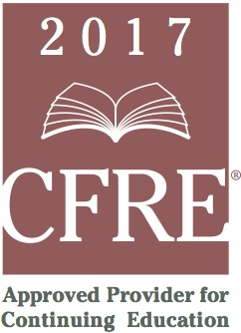
CFRE International has developed this form as a way for you to quickly track (and keep in your files!) the continuing education sessions you have attended. Simply check the boxes next to the sessions you attended. At the end of the conference, add up the total number of hours. Keep this sheet and you will be ready to complete your application form. All of the session slots listed are eligible for continuing education points on your CFRE application for initial certification and/or recertification. Sessions not listed here are not eligible for points.

CONTINUING EDUCATION POINTS TRACKER

Activity Organizer: ALDE
Title of Activity: Executive Fundraising Essentials
Names of Presenter(s): Various
Dates and Location: 7 November, 2017 – Cleveland, Ohio

Date: 7 November, 2017
9:00 am – 11:30 am CT (2.5 pts)
- Inside the Donor’s Mind: The Psychology of Fundraising – Heather McGinness
- Faith, Ministry and Philanthropy – Heather McGinness

12:30 pm – 2:45 pm CT (2.25 pts)
- The Case for Hiring an Advancement Staffer: Fundraisers are not ATMs! – Jon Dize
- Core Elements – Integration and Strategies – Jon Dize

Total number of points attained: ___________

